**DOMINICAN COLLEGE OF TARLAC**

Mac Arthur Highway, Poblacion (Sto.Cristo), Capas. 2315 Tarlac, Philippines

Tel.No. (045) 491-7579/Telefax (045) 925-0519

E-mail: domct _2315@yahoo.com

**COLLEGE DEPARTMENT**

A.Y. 2020-2021, First Semester

**OBE FACULTY - DESIGNED MODULE**

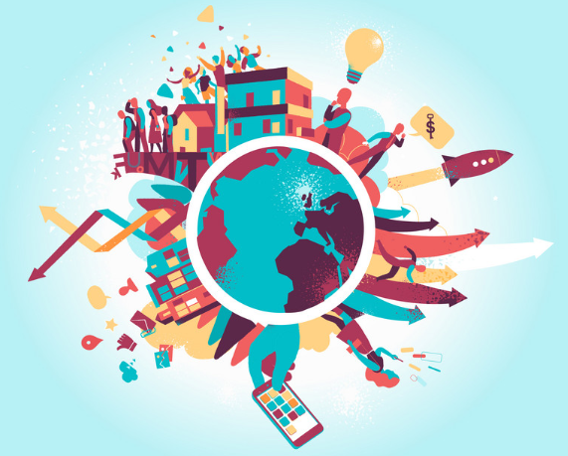

**THE CONTEMPORARY WORLD**

1. **Subject: GE3 - The Contemporary World**
2. **Learning Outcomes:**

-Explain the effects of globalization on governments.  
-Identify the institutions that govern international relations.  
-Explain the relevance of states amid globalization.

1. **Topic/Lesson:** The Global Interstate System
2. **Days of Learning Sessions:**

**Online/Modular**

BSCRIM 1A - Friday/Wednesday

BSCRIM 1B - Wednesday/Friday

BSCRIM 1C - Thursday/Saturday

1. **Expected Outcome:**

Distinguish the purpose of Global Interstate System

**VI.Delivery:**

1. **Thought Processing**
   1. **Pre-assessment Activity (Collaboration)**

**Activity 1.**

Identify the jumbled words below and write your answers on the space provided.

**A L B O G L**

**I T R S A T E T N E**

**N K B A**

_________________________ __________________________

**M T E Y S S**

__________________________

1. **Presentation Phase:**

**The 3-A Approach**

* 1. **ANALYSIS (Communication)**

**Analyze the significance of the jumbled words in activity 1.1 to the contemporary world, explain your answer briefly.**

________________________________________________________________________________________________________________________________________________________________________________________________________________________________________________________________________________________________________________________________________________________________________________________________

* 1. **ABSTRACTION (Critical Thinking)**

**Global Interstate System**

It is the whole system of human interactions. The modern world-system is structured politically as an interstate system – a system of competing and allying states. Political Scientists commonly call this the international system, and it is the main focus of the field of International Relations.   
 **STRENGTHS**

* It will make travel less cheaper, faster and better.

**WEAKNESSES**

Imposed long-term costs on the country

Cut down on competition between shippers and passenger carriers.

Rising consumption of gasoline led to air pollution and a dependence on oil that affected consumers and foreign policy for generations to come.

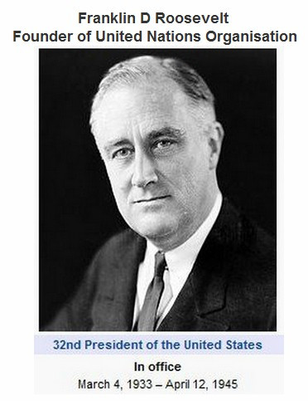**INSTITUTION**

Institution that govern international Relations

**1. UNITED NATION**

United States President FRANKLIN ROOSEVELT coined the name united nations that was used in the declaration of United Nation on 1 of January 1942. UN means allies to fight against the Axis Powers in the Second World War II. Only 26 nation’s representatives pledge their governments to:

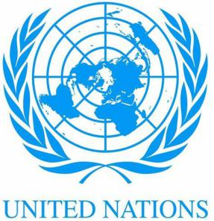 1. Each Government pledges itself to employ its full resources, military or economic, against those members of the tripartite pact and its adherents with which such government is at war.

2. Each Government pledges itself to cooperate with the Governments signatory hereto and not to make a separate armistice or peace with the enemies.

**2. International Financial Institutions**

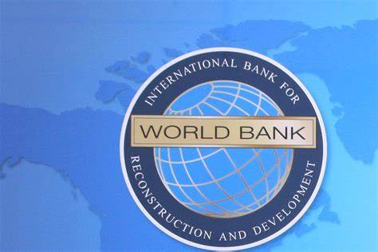**•WorldBank**  
  
The World Bank is an international organization that helps emerging market countries to reduce poverty. Its first goal is to end extreme poverty. It wants no more than 3% of people to live on $1.90 a day or less by 2030. Its second goal is to promote shared prosperity. It wants to improve the incomes of the bottom 40% of the population in each country. Since 1947, the World Bank has funded more than 12,000 projects.   
The World Bank is not a bank in the conventional sense of the word. Instead, it consists of two organizations. One is the International Bank for Reconstruction and Development. It provides loans, credit, and grants. The second is the International Development Association. It provides low- or no-interest loans to low-income countries.

**• - International Monetary Fund**

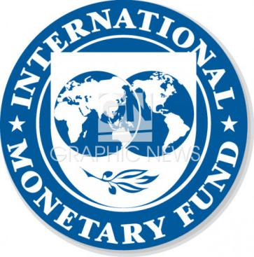The International Monetary Fund (IMF) is an organization of 189 countries, working to foster global monetary cooperation, secure financial stability, facilitate international trade, promote high employment and sustainable economic growth, and reduce poverty around the world.

Created in 1945, the IMF is governed by and accountable to the 189 countries that make up its near-global membership.

The IMF's [primary purpose](http://www.imf.org/external/np/exr/facts/glance.htm) is to ensure the stability of the international monetary system—the system of exchange rates and international payments that enables countries (and their citizens) to transact with each other. The Fund's mandate was updated in 2012 to include all macroeconomic and financial sector issues that bear on global stability.

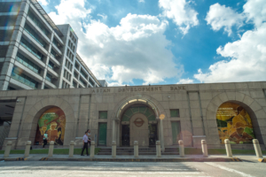**Asian Development Bank**

The bank was founded in the early 1960s to foster cooperation among Asian countries and spur economic growth in the region. In 1963, the United Nations Commission for Asia and the Far East held its first Ministerial Conference on Asian Economic Cooperation, where a resolution passed for the creation of this regional bank. The ADB was officially [created two years later](https://treaties.un.org/doc/source/titles/english.pdf) in Manila, the capital of the Philippines with 31 member states and Takeshi Watanabe residing as president.

The Asian Development Bank (ADB) is a regional bank aimed at [fostering social and economic development in Asia](https://www.bmz.de/en/ministry/approaches/multilateral_cooperation/players/RegionalDevelopmentBanks/ASDB/index.html). The history of the Asian Development Bank is that of an evolving institution, constantly shifting focus towards new problems and expanding its role in regional affairs.

**• - African Development Bank**

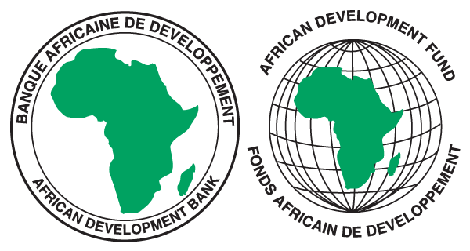Established to promote economic and social development efforts on the continent, the African Development Bank (AfDB) Group comprises three entities: the African Development Bank (AfDB) which is the parent institution, created following an agreement signed by 23 founding member states on August 14, 1963 in Khartoum, Sudan. This became effective on September 10, 1964. The group includes two concessionary windows – the African Development Fund (ADF), established on November 29, 1972 by the African Development Bank and 13 non-African countries; and the Nigeria Trust Fund (NTF), set up in 1976 by the Federal Government of Nigeria.

**FREE TRADE**

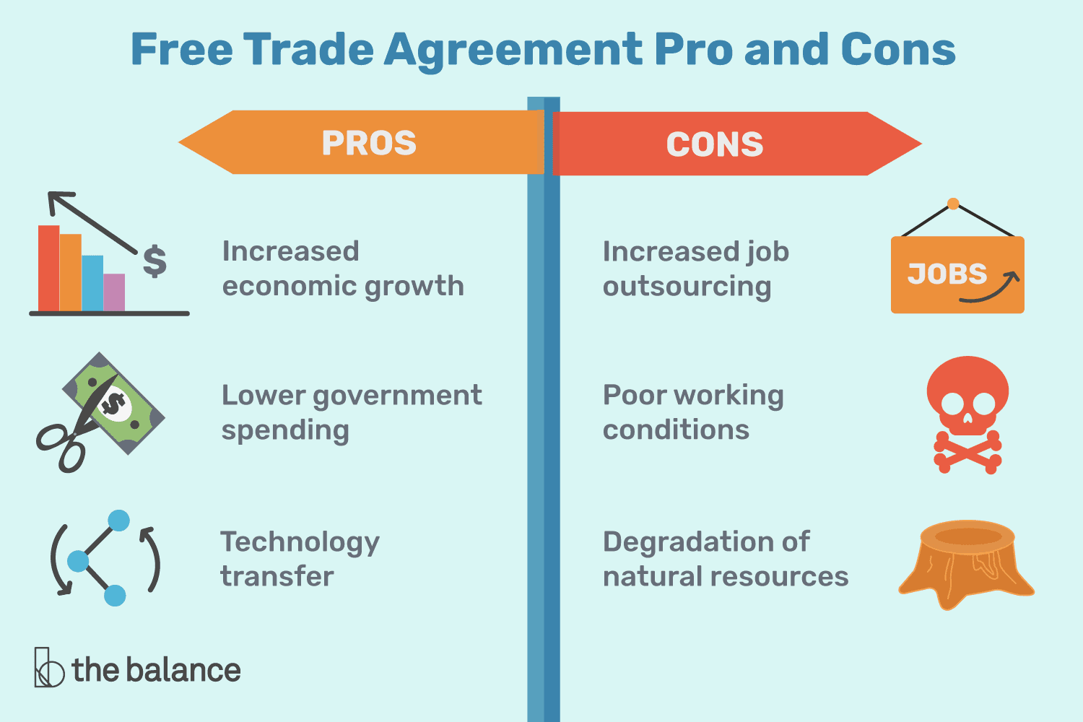**TRADE AGREEMENT**

Trade agreements are when two or more nations agree on the terms of trade between them. They determine the tariffs and duties that countries impose on imports and exports. All trade agreements affect international trade.

***IMPORTS***

are goods and services produced in a foreign country and bought by domestic residents. That includes anything shipped into the country even if it's by the foreign subsidiary of a domestic firm. If the consumer is inside the country's boundaries and the provider is outside, then the good or service is an import.

***EXPORTS***

Exports are goods and services that are made in a country and sold outside its borders. That includes anything shipped from a domestic company to its foreign affiliate or branch.

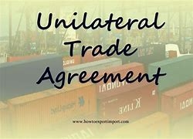**3 TYPES OF TRADE AGREEMENT**

***UNILATERAL***

It occurs when a country imposes trade restrictions and no other country reciprocates.

A country can also unilaterally loosen trade restrictions, but that rarely happens.

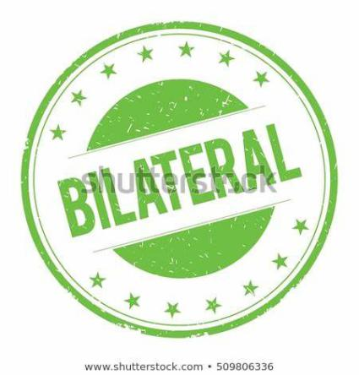

***BILATERAL***

are between two countries. Both countries agree to loosen trade restrictions to expand business opportunities between them. They lower tariffs and confer preferred trade status with each other.

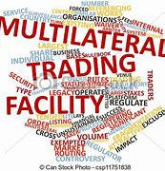

***MULTILATERAL***

are the most difficult to negotiate. These are among three countries or more. The greater the number of participants, the more difficult the negotiations are. They are also more complex than bilateral agreements. Each country has its own needs and requests.

Activity: With the disscusion above, process everything you learned by completing the table below.

|  |  |  |
| --- | --- | --- |
| **TERM** | **POSITIVE EFFECTS** | **NEGATIVE EFFECTS** |
| **GLOBAL INTERSTATE SYSTEM** |  |  |

* 1. **APPLICATION (Creativity):**

**1. With the definitions and functions of the terms discussed under the topic Global Interstate System, imagine that they do not exist at all, what do you think is the curret situation of the contemporary world?**

________________________________________________________________________________________________________________________________________________________________________________________________________________________________________________________________________________________________________________________________________________________________________________________________________________________________________________________________________________________________________________________________________________________________________________________________

________________________________________________________________________________________________________________________________

1. **Assessment Phase:** 
   1. **Quiz: Identification, write the correct answer on the space provided.**________________1. A system of competing and allying states.

________________2. An international organization that helps emerging market countries to reduce poverty. Its first goal is to end extreme poverty.

________________3. An organization of 189 countries, working to foster global monetary cooperation, secure financial stability, facilitate international trade, promote high employment and sustainable economic growth, and reduce poverty around the world.

________________4. A regional bank aimed at [fostering social and economic development in Asia](https://www.bmz.de/en/ministry/approaches/multilateral_cooperation/players/RegionalDevelopmentBanks/ASDB/index.html).

________________5. Are when two or more nations agree on the terms of trade between them. They determine the tariffs and duties that countries impose on imports and exports. All trade agreements affect international trade.

________________6. Are goods and services produced in a foreign country and bought by domestic residents.

________________7. Are goods and services that are made in a country and sold outside its borders.

________________8. It occurs when a country imposes trade restrictions and no other country reciprocates.

________________9. A trade agreement where both countries agree to loosen trade restrictions to expand business opportunities between them.

________________10. A trade agreement between three or more countries.

* 1. **Take Home Tasks/ Suggestive Readings:**

Read articles about Contemporary Global Governance

**VII. Reference/s:**

The Contemporary World by **Prince Kennex Reguyal Aldama,** published by REX Book Store, 2018